

Project Report

Metro-Rail-Ticket-Management-System



Table of Contents

1. Abstract 2

2. Introduction 2

3. Purpose of the project 3

4. Benefits of the project 6

5. Interim milestone dates for the project 7

6. Architectural design model 8

7. Project Description 9

8. Hardware and software requirement ......……………………………………….10

9. Flow Diagram 12

10. ER Diagram 13

11. Project developing resource 16

12. Project Module 17

13. Risk Analysis 22

14. Testing and Debuging 23

15. Project Delivary Plan 24

16. Future Plan 24

17. Conclusion 24

**Abstract:**

Bangladesh Railway (BR), is the state-owned rail transport agency of [Bangladesh](https://en.wikipedia.org/wiki/Bangladesh). It operates and maintains the entire railway network of the country. BR is controlled by the Directorate General of Bangladesh Railway under the Ministry of Railways along with Bangladesh Railway Authority (BRA) and which works for policy guidance of BR.

To focus on vision 2021 with government People’s Republic of Bangladesh make our country as digital Bangladesh. Then we have to digitalize our transportation system. We want to go modern era of transportation system by Metro-Rail. We propose an online service, that give possibility to buy ticket of metro rail between two station using web interface.

**Introduction:**

This system is basically concerned with the reservation and cancellation of railway tickets to the passenger. The need of this system arouses because as is the known fact that Metro-Rail has the largest railway network in our counter and it is not possible to handle such a large system manually. By computerizing it, it became possible to overcome the limitations and make the system operations more efficient. The complexity in handling data and records of such a vast system got reduced and became easier by computerizing the system.

Being more specific, this online railway reservation system can perform the basic. The users are required to register on the server for getting access to the database and query result retrieval. Upon registration completion, each user has an account which is essentially referred to as the ‘view level’ of the customer. The account contains comprehensive information of the user entered during the registration and allows the user to access their past reservations, cancellations, enquire about trains and train schedule, seat availability and make afresh reservations. The user will also be able to update their account details, etc.

The master user of this system is the Railway Administrator who can login using a master password and once a user is authenticated as the admin, he/she can access and modify information stored in the database of this system. This includes adding and updating of train, station, train routes and also managing the user and the passenger details

## Purpose:

Metro rail service become more familiar now a days. Many people travels via train many times in a day to their destination. But the major problem is ticket management system. It is not possible to ensure that there is a ticket available or not in a particular schedule via remote place. We want to provide SMS service that will give opportunities to check whether ticket is available or not and a way to conform ticket.

The basic functions being performed by our system are :

1. RESERVATION MANAGEMENT
2. TIMETABLE MANAGEMENT

These functions will be handled with the help of following sub functions: -

* It reserves and cancels seats for the passenger.
* It contains information about the trains.
* It contains information about the passenger.
* It contains the details of reservation fees, any concessions etc.
* It makes entries for reservation, waiting, cancelled tickets.
* It will update for uptime and downtime trains.

## Benefits of the project:

The project benefits are below:

1. Save time for passenger.
2. Comfortable way to buy ticket.
3. Remote way to buy ticket.
4. Less suffering.
5. Reduce ticket Black market.

### **Interim milestone dates for the project:**

We want to finish our project within July 2017.

|  |  |
| --- | --- |
| Dates | Work plan |
| February’17 – March’17 | Design complete schema |
| March’17 – April’17 | Choose available resource like programming language platform or framework, database and required tools |
| April’ 17 – June’17 | Implementation |
| June’ 17 – July’17 | Test and error analysis . |
| July’ 17 (2nd week) | final project lunch |

**Architectural design model for Project:**

We use waterfall model to design our project.

We also use MVC format for codding style. We divide our work like planning, resource management, codding, debugging, error testing.

The system has a three-level architecture:

* The first level (front end) uses html, CSS, JavaScript to provide the users with the front-end.
* The lower lever (back end) uses MS SQL Server to house the database.
* The middle level comes into play only when Available tours are to be searched. This is achieved through the use of Active X Components (Data Grid). This picks up the requisite data from the database (depending upon the tours available and any other required conditions) and uses them to show the available tours.

**Project description:**

### We chose PHP: Hypertext Preprocessor as backend language for developing our project. We use also Hypertext Markup Language (HTML), [Cascading Style Sheets](https://www.google.com/url?sa=t&rct=j&q=&esrc=s&source=web&cd=1&cad=rja&uact=8&ved=0ahUKEwiLl92u8IvVAhWCIsAKHWKcAm0QFggjMAA&url=https%3A%2F%2Fen.wikipedia.org%2Fwiki%2FCascading_Style_Sheets&usg=AFQjCNFfHTC5k9zcnyyyplbdFr568Ytlzw)(CSS), JavaScript(JS), Bootstrap for front end. We use MySQL server 5.6 to use as database for storing data.

For administration, he can log in database and website by authorized password. if he is authorized only he can get access. But an anonymous user can see train schedule. But get or book ticket he has to log in.If he is not registered before the he has to sing up by gibe his username, password and mail address. We conform this authorization as a user when his mail address as verified.

When he log in as a user then the get option to view schedule, book ticket, Cancel ticket , and view ticket status by PNR system. If he confirm his ticket for a specific day and he want to cancel his ticket before journey he can canceled his ticket but before 24 hours.

MySQL server is basically a database server which is mostly used for storing user data into the required database in a specific table for easy access of these data in the future. The database server works when a local application invokes it. Before storing data into a database with the help of database server, PHP sends a SQL query to MySQL database server for establishing a connection to the server by using the loopback address, i.e., 127.0.0.1 along with the user name and password for getting authentication from the database server. Since connection is established locally with the database server by PHP, so there is no chance of getting access to database server for modifying database by the client.

Also , when PHP request for information retrieval from the database server by sending SQL query then the database server sends back the result of query after executing it by the database server. Another method of accessing database server is only possible by locally, i.e., only administrator of that particular computer can get all the access facilities of the database server as well as all the database which are not available to restricted users. PHP can update information in the database server if it has the administrator username and password to access the specific database, otherwise connection will be rejected by MySQL server and the database cannot be updated.

### 

**Hardware and software requirement to run project**

HARDWARE REQUIREMENT:

Processor Pentium IV Processor or higher

Processor Speed 850 MHz or higher

Hard Disk 80GB or higher

Main Memory 1 GB SD RAM or higher

Display Type SVGA Color Monitor

SOFTWARE REQUIREMENT

Running platfrom(Browser) Any Browser (Mozilla Firefox, Chrome, Opera etc)

Server Side Script (Front end) Html,CSS,JavaScript

Back End PHP

Database MY-SQL SEVER 5.6

Operating System Windows vista Xp, 7. ,8 8.1, 10

**Flow Diagram of the Project:**

**Use-case Diagram**

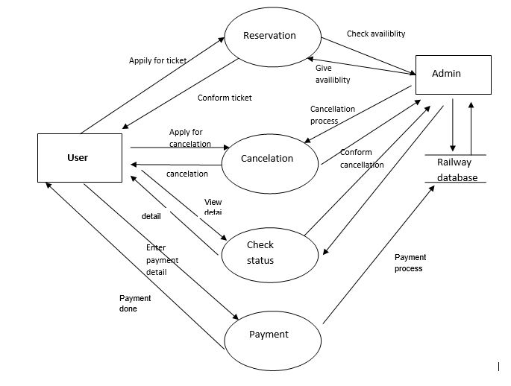

**State Diagram**

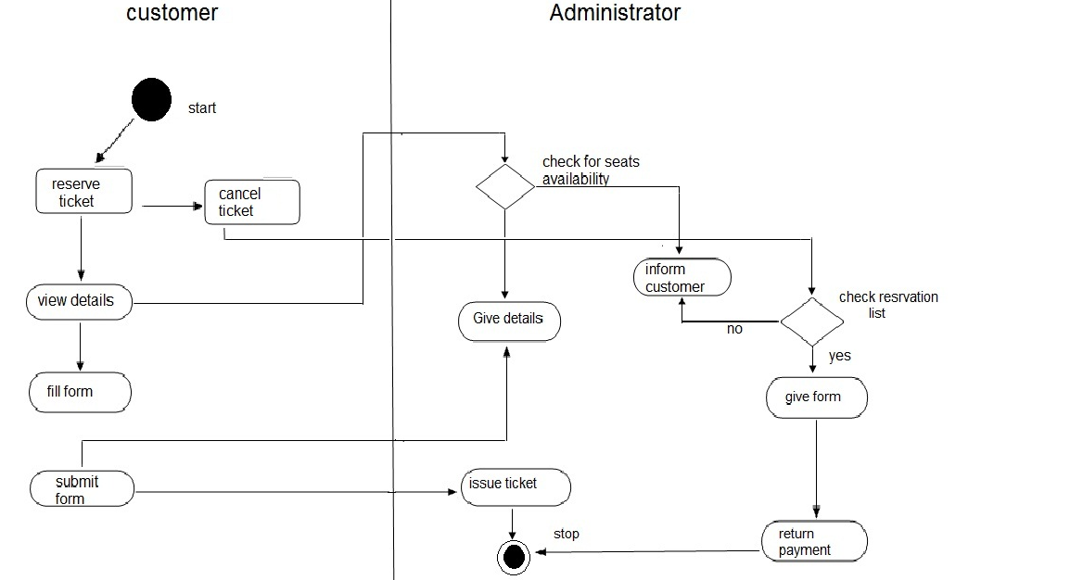

**Project entity relationship diagram (ERD):**

We have 6 entity in our database and also have a admin which can control all entity and sub entity.

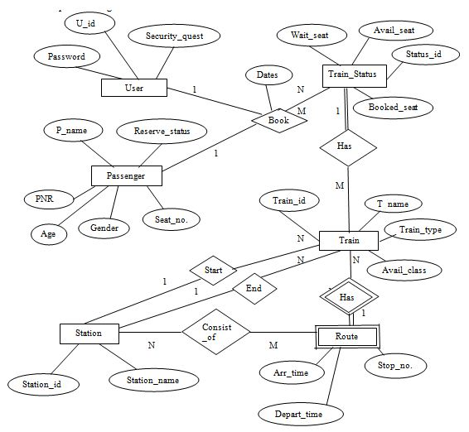

**Input data Flow Chart**

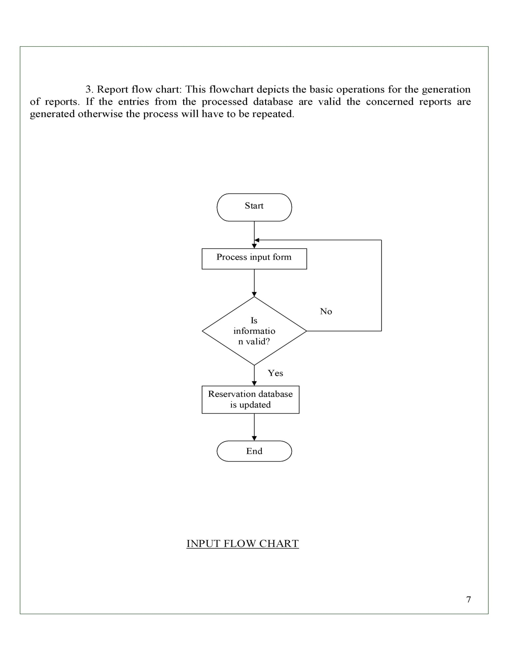

**Output data Flow Chart**

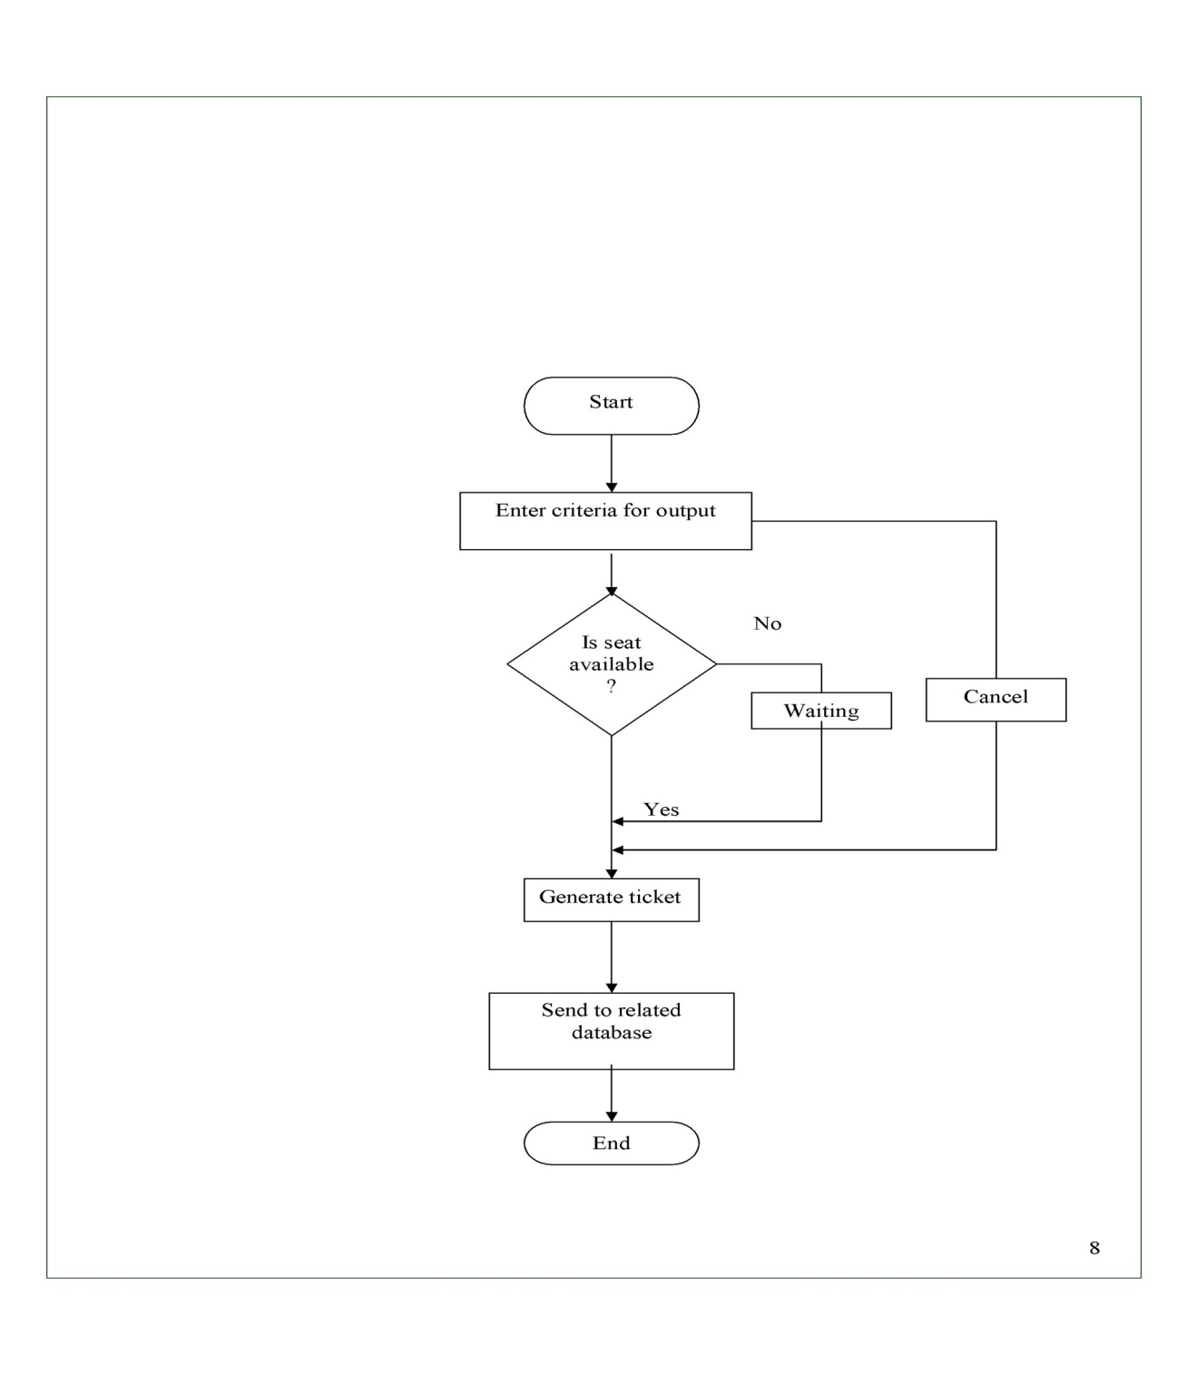

**Ticket conformation Flow Chart**

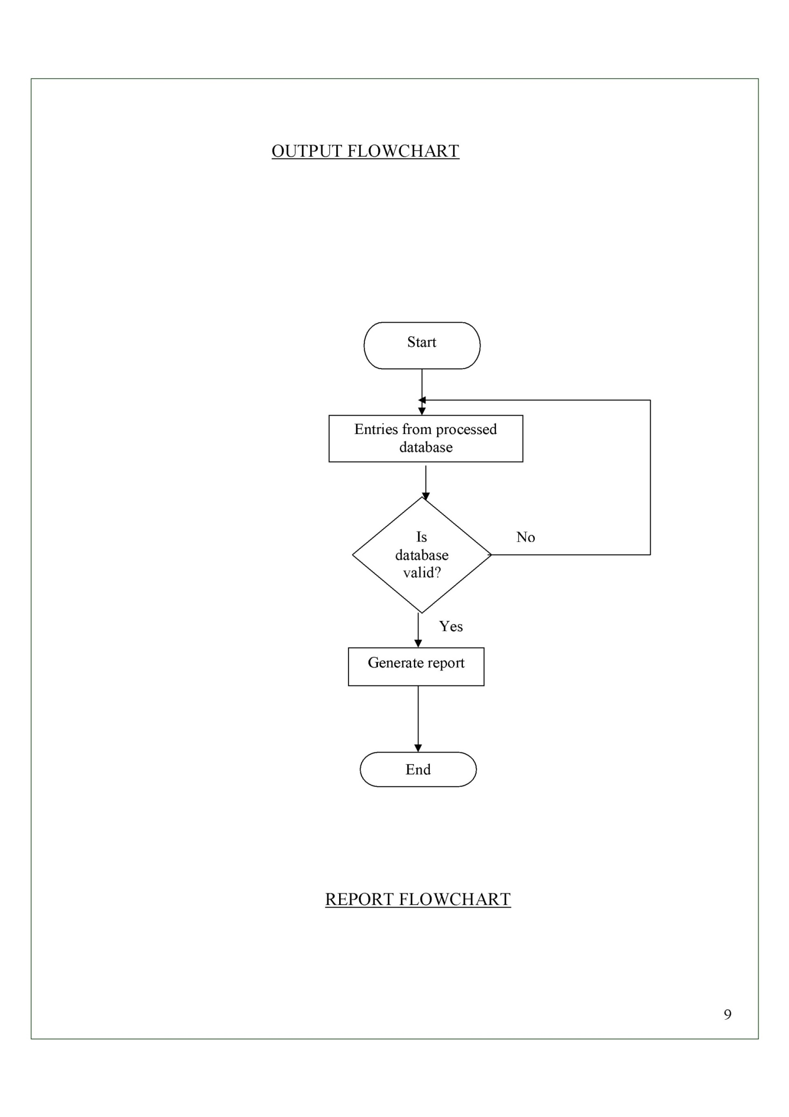

**Project developing resource:**

**Developing ide** : [PhpStorm 2017.1](https://www.google.com/url?sa=t&rct=j&q=&esrc=s&source=web&cd=1&cad=rja&uact=8&ved=0ahUKEwjdqJq49IvVAhVMgI8KHSNjCgEQFggmMAA&url=https%3A%2F%2Fwww.jetbrains.com%2Fhelp%2Fphpstorm%2Fviewing-description-of-a-task.html&usg=AFQjCNGiH5rbFLw43i4FqZv3mJSAYwKg9Q)

### We use [PhpStorm 2017.1](https://www.google.com/url?sa=t&rct=j&q=&esrc=s&source=web&cd=1&cad=rja&uact=8&ved=0ahUKEwjdqJq49IvVAhVMgI8KHSNjCgEQFggmMAA&url=https%3A%2F%2Fwww.jetbrains.com%2Fhelp%2Fphpstorm%2Fviewing-description-of-a-task.html&usg=AFQjCNGiH5rbFLw43i4FqZv3mJSAYwKg9Q) to develop our project.

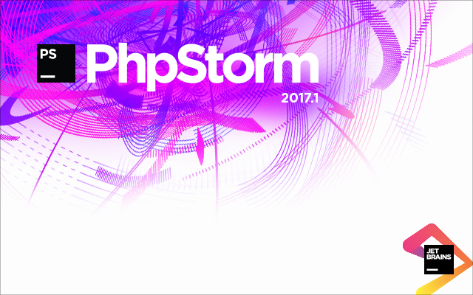JetBrains PhpStorm is a commercial, cross-platform [IDE](https://en.wikipedia.org/wiki/Integrated_Development_Environment) for [PHP](https://en.wikipedia.org/wiki/PHP) built on [JetBrains' IntelliJ IDEA](https://en.wikipedia.org/wiki/JetBrains) platform.PhpStorm provides an editor for [PHP](https://en.wikipedia.org/wiki/PHP), [HTML](https://en.wikipedia.org/wiki/HTML) and [JavaScript](https://en.wikipedia.org/wiki/JavaScript) with on-the-fly code analysis, error prevention and automated [refactorings](https://en.wikipedia.org/wiki/Refactoring) for PHP and JavaScript code.

PhpStorm's [code completion](https://en.wikipedia.org/wiki/Code_completion) supports PHP 5.3, 5.4, 5.5, 5.6 & 7.0 (modern and legacy projects), including [generators](https://en.wikipedia.org/wiki/Generator_%28computer_programming%29), [coroutines](https://en.wikipedia.org/wiki/Coroutines), the finally keyword, list in foreach, [namespaces](https://en.wikipedia.org/wiki/Namespace), [closures](https://en.wikipedia.org/wiki/Closure_%28computer_science%29), [traits](https://en.wikipedia.org/wiki/Trait_%28computer_programming%29) and short array syntax. It includes a full-fledged [SQL](https://en.wikipedia.org/wiki/SQL) editor with editable query results.

All features available in [WebStorm](https://en.wikipedia.org/wiki/WebStorm) are included in PhpStorm, which adds support for PHP and databases.WebStorm ships with pre-installed JavaScript plugins (such as for [Node.js](https://en.wikipedia.org/wiki/Node.js)), which are available for PhpStorm as well at no cost.

**PHP:**

PHP is a server scripting language, and a powerful tool for making dynamic and interactive Web pages.PHP is a widely-used, free, and efficient alternative to competitors such as Microsoft's ASP.

PHP is one of the simplest server-side languages out there, and it was designed primarily for web development. Learning PHP is good not only because it adds one more language to your toolbelt, but also because there is a large number of sites currently built with Wordpress, a content management system (CMS) built with PHP.

**Hypertext Markup Language (HTML):**

Hypertext Markup Language (HTML) is the standard [markup language](https://en.wikipedia.org/wiki/Markup_language) for creating [web pages](https://en.wikipedia.org/wiki/Web_page) and [web applications](https://en.wikipedia.org/wiki/Web_application). With [Cascading Style Sheets](https://en.wikipedia.org/wiki/Cascading_Style_Sheets) (CSS) and [JavaScript](https://en.wikipedia.org/wiki/JavaScript) it forms a triad of cornerstone technologies for the [World Wide Web](https://en.wikipedia.org/wiki/World_Wide_Web).[Web browsers](https://en.wikipedia.org/wiki/Web_browser) receive HTML documents from a [webserver](https://en.wikipedia.org/wiki/Webserver) or from local storage and render them into multimedia web pages. HTML describes the structure of a web page [semantically](https://en.wikipedia.org/wiki/Semantic) and originally included cues for the appearance of the document.

**Cascading Style Sheets (CSS)**

Cascading Style Sheets (CSS) is a [style sheet language](https://en.wikipedia.org/wiki/Style_sheet_language) used for describing the [presentation](https://en.wikipedia.org/wiki/Presentation_semantics) of a document written in a [markup language](https://en.wikipedia.org/wiki/Markup_language).Although most often used to set the visual style of [web pages](https://en.wikipedia.org/wiki/Web_page) and user interfaces written in [HTML](https://en.wikipedia.org/wiki/HTML) and [XHTML](https://en.wikipedia.org/wiki/XHTML), the language can be applied to any [XML](https://en.wikipedia.org/wiki/XML) document, including [plain XML](https://en.wikipedia.org/wiki/Plain_Old_XML), [SVG](https://en.wikipedia.org/wiki/Scalable_Vector_Graphics) and [XUL](https://en.wikipedia.org/wiki/XUL), and is applicable to rendering in [speech](https://en.wikipedia.org/wiki/Speech_synthesis), or on other media. Along with HTML and [JavaScript](https://en.wikipedia.org/wiki/JavaScript), CSS is a cornerstone technology used by most websites to create visually engaging webpages, user interfaces for [web applications](https://en.wikipedia.org/wiki/Web_applications), and user interfaces for many mobile applications.

**JavaScript**

JavaScript is a high-level, dynamic, untipped, and interpreted programming language. It has been standardized in the ECMAScript language specification. Alongside HTML and CSS, JavaScript is one of the three core technologies of World Wide Web content production.

the majority of websites employ it, and all modern Web browsers support it without the need for plug-ins. JavaScript is prototype-based with first-class functions, making it a multi-paradigm language, supporting object-oriented, imperative, and functional programming styles.

**Bootstrap:**

Bootstrap is a [free and open-source](https://en.wikipedia.org/wiki/Free_and_open-source_software) front-end [web framework](https://en.wikipedia.org/wiki/Web_framework) for designing [websites](https://en.wikipedia.org/wiki/Website) and [web applications](https://en.wikipedia.org/wiki/Web_application). It contains [HTML](https://en.wikipedia.org/wiki/HTML)- and [CSS](https://en.wikipedia.org/wiki/CSS)-based design templates for [typography](https://en.wikipedia.org/wiki/Typography), forms, buttons, navigation and other interface components, as well as optional [JavaScript](https://en.wikipedia.org/wiki/JavaScript) extensions. Unlike many web frameworks, it concerns itself with [front-end development](https://en.wikipedia.org/wiki/Front-end_web_development) only.

**MySQL:**

MySQL is an [open-source](https://en.wikipedia.org/wiki/Open-source) [relational database management system](https://en.wikipedia.org/wiki/Relational_database_management_system) (RDBMS).Its name is a combination of "My", the name of co-founder [Michael Widenius](https://en.wikipedia.org/wiki/Michael_Widenius)' daughter and "[SQL](https://en.wikipedia.org/wiki/SQL)", the abbreviation for [Structured Query Language](https://en.wikipedia.org/wiki/Structured_Query_Language). The MySQL development project has made its [source code](https://en.wikipedia.org/wiki/Source_code) available under the terms of the [GNU General Public License](https://en.wikipedia.org/wiki/GNU_General_Public_License), as well as under a variety of [proprietary](https://en.wikipedia.org/wiki/Proprietary_software) agreements. MySQL was owned and sponsored by a single [for-profit](https://en.wikipedia.org/wiki/Business) firm, the [Swedish](https://en.wikipedia.org/wiki/Sweden) company [MySQL AB](https://en.wikipedia.org/wiki/MySQL_AB), now owned by Corporation. For proprietary use, several paid editions are available, and offer additional functionality.

**Project module:**

When we run this project first we get welcome page then we get option named:

* Train info
* User
* Admin
* Sign up

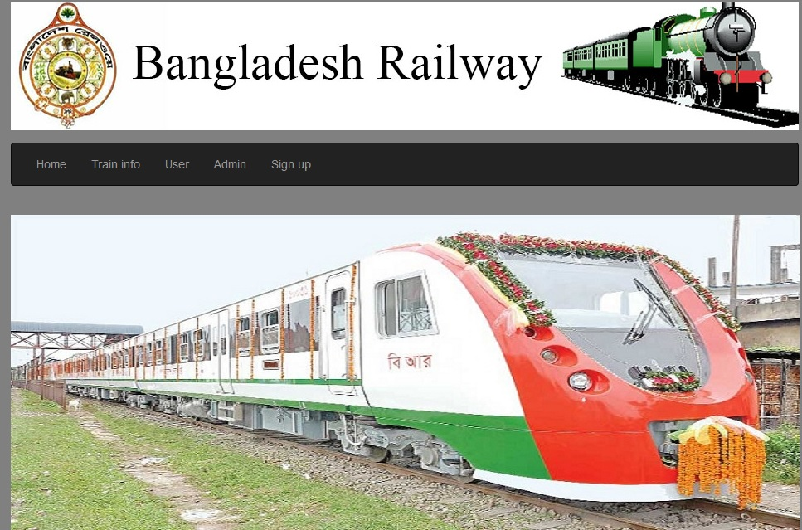

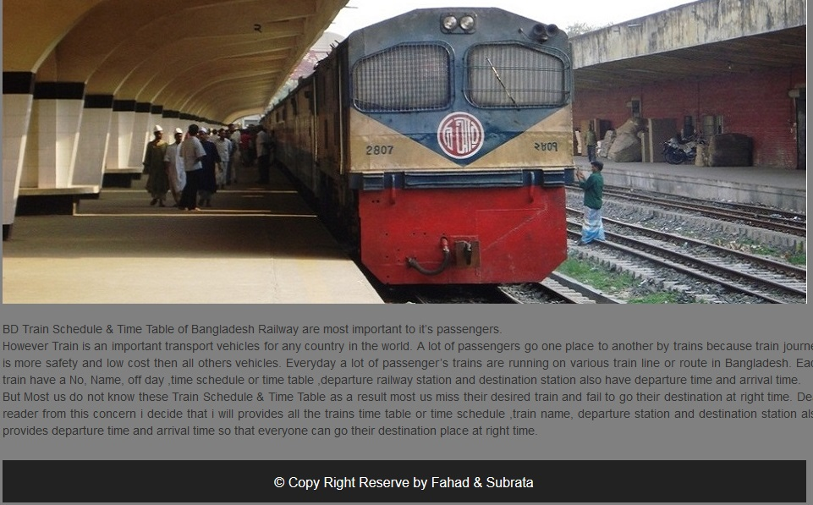

**Sign Up Module:**

An user can get privilege for metro rail ticket by resister this page by signup module and his data store our server site database.

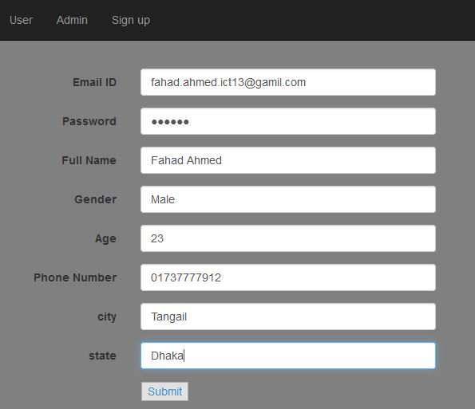

**Train info module:**

An anonymous user can see the train information by click this module.

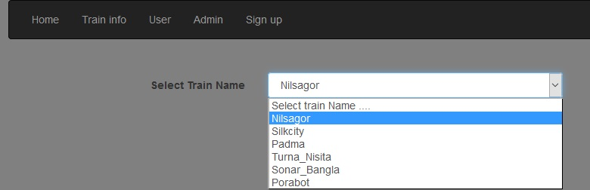

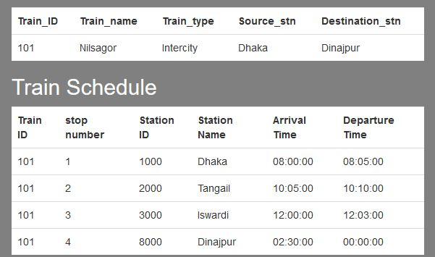

**Admin module:**

After log in as an admin, he can add train, update train schedule, add or update train route, update passenger ticket or cancel ticket, add train seat number.

When an admin log in then his username and password have to be checked for authorization

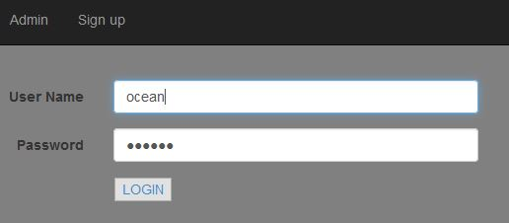

Then he get four option add train, train status, add route and logout.

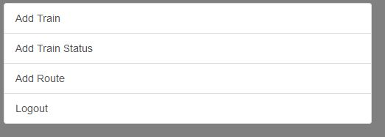

**Add train module:**

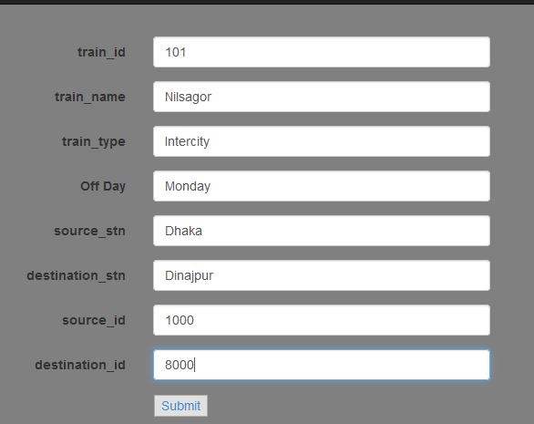

Allocating seat for a train of specific date

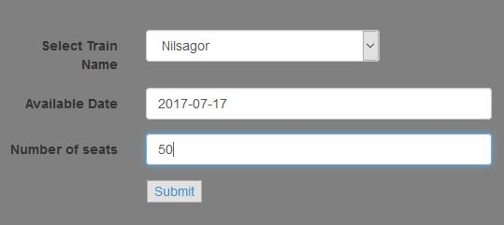

**Train routs**

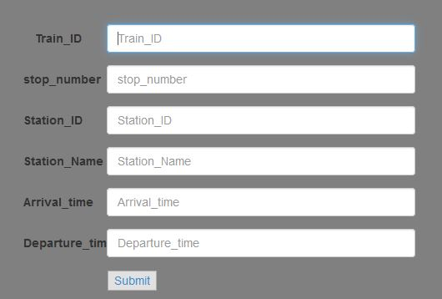

**User module:**

For an user first have to login then he get option named: view schedule, train between station, booking, passenger name record (PNR) ,cancel and logout.

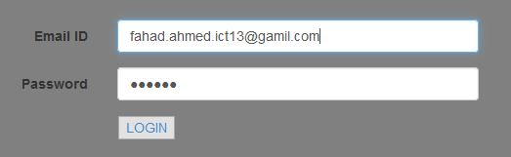

After login option

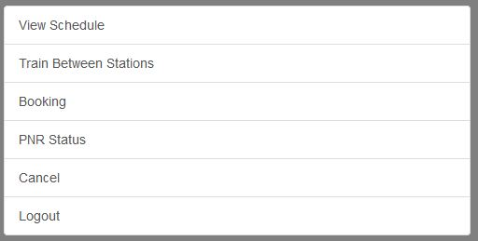

User can see train schedule

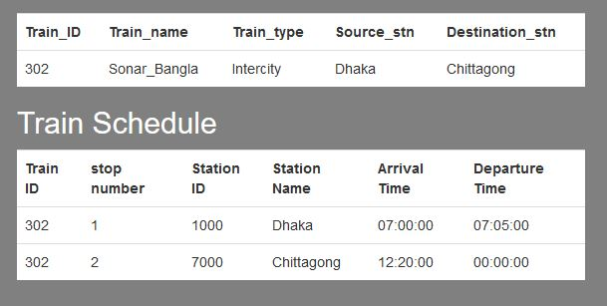

User can book ticket in specific date

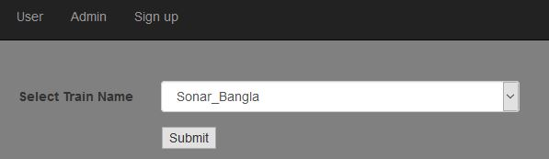

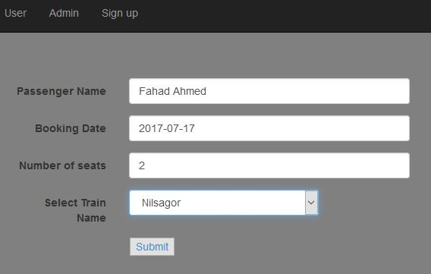

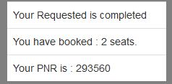

After confirm ticket he can check his ticket status by PNR : passenger name record system

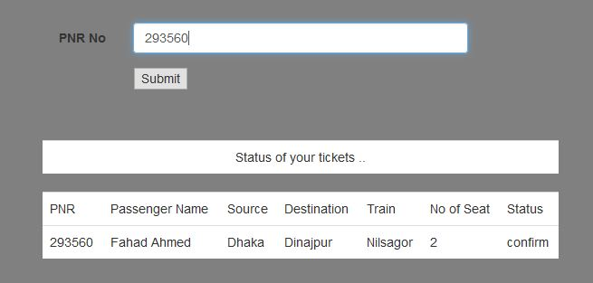

User can also cancel ticket before 24 ours by cancel module with PNR number

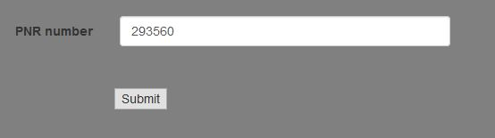

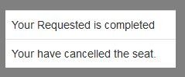

**Risk Analysis**

There are different types of Risk is present

**Cyber hack and database fall down:**

Our project is online base system and it feces as public requirement. So Cyber attack is one of the most important risk for our project. Another issue is database jam. In big occasion like Eid or holyday a huge amount load face the database. So it is a big risk for this project.

**Group Member turnover:**

When a Group member turn over then the overall project gets difficult to complete as the task provided to the concern person will be in pending and in order to complete that task we need to find the same skilled person to finished on time which is very difficult.

**Technology Change:**

Every application or software has a specification in which it has to work before launching the product if the technology change then it’s a major loss.

**Financial Risk:**

Once we start developing our software the cost for completing the product should complete as specified if it exceeds then it becomes a big risk.

**Project Testing:**

Testing is the process of exercising software with the intent of finding errors and ultimately correcting them. The following testing techniques have been used to make this project free of errors.

**white box testing:**

We use white box or clear box testing or glass box testing to test our system. This testing can be applied at the unit, integration and system levels of the software testing process.

*Content Review*

The whole content of the project has been reviewed thoroughly to uncover typographical errors, grammatical error and ambiguous sentences.

*Navigation Errors*

Different users were allowed to navigate through the project to uncover the navigation errors. The views of the user regarding the navigation flexibility and user friendliness were taken into account and implemented in the project.

*Unit Testing*

Focuses on individual software units, groups of related units.

* *Unit – smallest testable piece of software.*
* *A unit can be compiled /assembled / linked/loaded; and put under a test harness.*
* *Unit testing done to show that the unit does not satisfy the application and /or its implemented software does not match the intended designed structure.*

*Integration Testing*

Focuses on combining units to evaluate the interaction among them

**Project Delivery Plans**

We will deliver a project that will provide a user-friendly software which will help the user the location of the nearby bus stop and a web interface database. We will deliver the project 2nd week of July 2017.

**Future plan :**

Our future plan for this project is to make it more commercial. we want to convert it as android and iPhone platform.

# **Conclusion:**

The main aim of developing Reservation system is to provide all information that is required by the users. User friendliness is a must that is the user must get the details without complicated searching procedures. Other important requirements of software are data security, extensibility and maintainability. All these features are included in this web application.

The project greatly helped in understanding the various phases in website development and exposure to a new developer platform PHP and database MS SQL Server.